TABLE OF CONTENTS

- TENDER FORM
- TENDER SECURING DECLARATION
- PRICE SCHEDULE
- BROCHURES / SAMPLES
- MANUFACTURER’S AUTHORISATION
- CERTIFICATE OF WARRANTY
- WARRANTY

- POWER OF ATTORNEY

- REFERENCES
- COMPANY PROFILE
- COMPANY CERTIFICATES
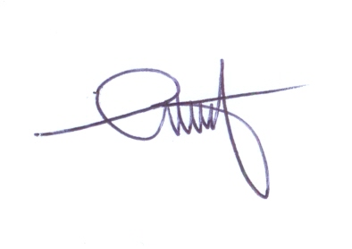

- FINANCIAL STATEMENT

